WEEK 4 INTERNSHIP REPORT

Machine Learning Model Development and Evaluation

Internship: Data Science with Python Internship

Dataset: Student Performance Dataset
INTRODUCTION:
Machine learning can be used to identify patterns in student data and make predictions based on information available about students. In this project, the Student Performance dataset was used to develop a classification model that predicts whether a student belongs to a Lower Performance or Higher Performance group. The dataset contains 1,044 student records from Mathematics and Portuguese subjects. A binary target variable was created using the final grade (G3). Students with a final grade below 12 were classified as Lower Performance, while students with a grade of 12 or above were classified as Higher Performance. The main objective was to develop and evaluate a Logistic Regression model and determine how accurately it could classify student performance. A Decision Tree model was also developed for comparison. Different evaluation metrics and visualizations were used to understand the strengths, limitations, and errors of the models. This analysis provides a practical example of how machine learning can be applied to educational data while highlighting the importance of proper preprocessing, model evaluation, and careful interpretation of results.

PROJECT OBJECTIVE AND MACHINE LEARNING PROBLEM:
The main objective of this project was to develop and evaluate a machine learning model that could classify students into Lower Performance and Higher Performance groups. The classification was based on student characteristics, study-related factors, previous academic information, family background, and lifestyle-related variables.
The target variable, performance, was created from the final grade (G3). Students with a final grade below 12 were assigned to the Lower Performance group (0), while students with a final grade of 12 or above were assigned to the Higher Performance group (1). The dataset was relatively balanced, with 534 students (51.15%) in the Lower Performance group and 510 students (48.85%) in the Higher Performance group. This balanced distribution reduced the risk of misleading results caused by class imbalance.The primary model selected for the task was Logistic Regression, which is suitable for binary classification and provides interpretable predictions. A Decision Tree Classifier was also trained using the same training and testing data to provide a direct comparison between two machine learning approaches. The main research question was: How accurately can student-related features predict whether a student will belong to the Lower Performance or Higher Performance group?

DATASET DESCRIPTION AND DATA PREPARATION:
The analysis used the Student Performance dataset containing information about students enrolled in Mathematics and Portuguese courses. The two subject datasets were combined to create a dataset of 1,044 student records and 34 columns. A subject variable was added to identify whether each record came from the Mathematics or Portuguese dataset. The dataset contains academic, demographic, family, social, and lifestyle-related variables. For the machine learning model, 11 features were selected: age, study time, previous failures, absences, mother's education, father's education, travel time, going out frequency, health status, family relationship quality, and free time.
Before model training, the selected features were checked for data quality. The analysis found 0 missing values across all 11 selected features and 0 duplicate rows, so no imputation or duplicate removal was required. A binary target variable called performance was then created from the final grade (G3). Students with G3 < 12 were classified as Lower Performance (0), while students with G3 >= 12 were classified as Higher Performance (1). The final grade was excluded from the input features to prevent target leakage and ensure that the model did not directly use the outcome it was trying to predict.
Dataset Context:
The dataset used in this project represents student information collected for the Student Performance dataset and includes academic, demographic, family, social, and lifestyle-related characteristics. The data is cross-sectional rather than time-series data, meaning that the analysis does not examine changes in student performance over a specific period of time. Instead, each record represents student-related information and performance outcomes available within the dataset. Therefore, the model predictions should be interpreted within the context of the dataset and should not be treated as evidence of changes or trends over time.

DATA SPLITTING AND PREPROCESSING:
To evaluate the machine learning models fairly, the dataset was divided into separate training and testing sets. An 80:20 split was used, resulting in 835 training records and 209 testing records. The random_state was set to 42 so that the data split could be reproduced. Stratified sampling was applied during the split to maintain the original balance between the two performance groups. In the training dataset, 51.14% of students were classified as Lower Performance and 48.86% as Higher Performance. The testing dataset had a very similar distribution of 51.20% Lower Performance and 48.80% Higher Performance. This ensured that the test data was representative of the original dataset. The selected numerical features were then standardized using StandardScaler. The scaler was fitted only on the training data and then applied to the testing data. This was done to place features with different numerical ranges on a comparable scale while avoiding information leakage from the test set into the training process.

Code snippet:
X_train, X_test, y_train, y_test = train_test_split(
X,
y,
test_size=0.20,
random_state=42,
stratify=y
)
print("Training samples:", len(X_train))
print("Testing samples:", len(X_test))
print("\nTraining class distribution:")
print(y_train.value_counts(normalize=True).mul(100).round(2))
print("\nTesting class distribution:")
print(y_test.value_counts(normalize=True).mul(100).round(2))

MODEL SELECTION AND TRAINING:
Two machine learning classification models were developed and evaluated: Logistic Regression and a Decision Tree Classifier.
Logistic Regression was selected as the primary model because the task involves binary classification, with students classified as either Lower Performance or Higher Performance. It is also a relatively simple and interpretable model, making it suitable for understanding the relationship between the selected features and the predicted outcome.
A Decision Tree Classifier was trained as a comparison model. Unlike Logistic Regression, a Decision Tree can capture more complex and non-linear relationships between features. The tree depth was limited to 5 to control model complexity and reduce the risk of overfitting.
Both models were trained using the same training data, while the same unseen test set of 209 records was used for evaluation. This allowed a fair comparison between the two approaches.

Code Snippet used for Logistic Regression:
logistic_model = LogisticRegression(
random_state=42,
max_iter=1000
)
logistic_model.fit(
X_train_scaled,
y_train
)
print("Logistic Regression model trained successfully.")
Code Snippet used for Decision Tree:
tree_model = DecisionTreeClassifier(
max_depth=5,
random_state=42
)
tree_model.fit(X_train, y_train)

MODEL EVALUATION METRICS:
The models were evaluated using multiple performance metrics rather than accuracy alone. This provides a more complete assessment of how effectively each model classified students in the unseen test dataset.
The following metrics were used:
- Accuracy: The proportion of all predictions that were correct.
- Precision: The proportion of students predicted as Higher Performance who were actually in the Higher Performance group.
- Recall: The proportion of actual Higher Performance students correctly identified by the model.
- F1-Score: A balanced measure that combines precision and recall.
- ROC-AUC: Measures how effectively the model distinguishes between the Lower and Higher Performance groups across different classification thresholds.

Logistic Regression Results
Metric | Result
Accuracy | 65.07%
Precision | 62.83%
Recall | 69.61%
F1-Score | 66.05%
ROC-AUC | 70.76%
The Logistic Regression model correctly classified approximately 65 out of every 100 students in the unseen test data. Its recall of 69.61% shows that it successfully identified a relatively larger proportion of actual Higher Performance students. The ROC-AUC score of 0.7076 also indicates that the model performed better than random classification, although its overall predictive ability remained moderate.
Code Snippet used for Evaluation:
accuracy = accuracy_score(y_test, y_pred)
precision = precision_score(y_test, y_pred)
recall = recall_score(y_test, y_pred)
f1 = f1_score(y_test, y_pred)
roc_auc = roc_auc_score(y_test, y_prob)

CONFUSION MATRIX AND ERROR ANALYSIS:
The confusion matrix provides a detailed view of the Logistic Regression model's correct and incorrect predictions on the 209 unseen test records.
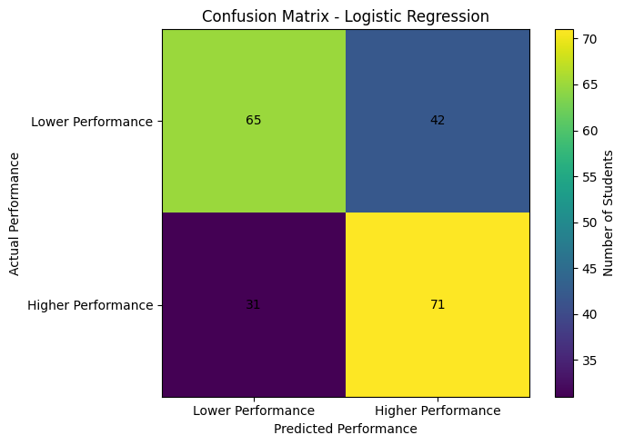Figure 1: Confusion Matrix for Logistic Regression
The model correctly classified 65 Lower Performance students and 71 Higher Performance students, giving a total of 136 correct predictions. However, it also made 73 incorrect predictions. Specifically, the model produced 42 false positives, where a student was predicted as Higher Performance but actually belonged to the Lower Performance group. It produced 31 false negatives, where a student was predicted as Lower Performance but actually belonged to the Higher Performance group. The False Positive Rate was 39.25%, while the False Negative Rate was 30.39%. The overall error rate was 34.93%.
These results show that the model was somewhat more likely to incorrectly classify a Lower Performance student as Higher Performance than to miss an actual Higher Performance student. This is an important limitation because an incorrect positive prediction could give an overly optimistic assessment of a student's expected performance.
Confusion Matrix Code Snippet:
cm = confusion_matrix(y_test, y_pred)
plt.figure(figsize=(7, 5))
plt.imshow(cm)
plt.title("Confusion Matrix - Logistic Regression")
plt.xlabel("Predicted Performance")
plt.ylabel("Actual Performance")
plt.xticks([0, 1], ["Lower Performance", "Higher Performance"])
plt.yticks([0, 1], ["Lower Performance", "Higher Performance"])
for i in range(2):
for j in range(2):
plt.text(j, i, cm[i, j], ha="center", va="center")
plt.colorbar(label="Number of Students")
plt.tight_layout()
plt.show()
ROC CURVE ANALYSIS:
The ROC (Receiver Operating Characteristic) curve was used to evaluate how well the Logistic Regression model could distinguish between Lower Performance and Higher Performance students across different classification thresholds.
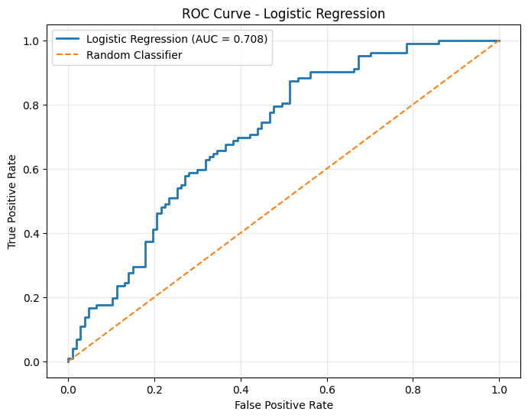
Figure 2: ROC Curve for Logistic Regression
The Logistic Regression model achieved a ROC-AUC score of 0.7076. An AUC value of 0.5 would indicate performance similar to random guessing, while a value closer to 1.0 would indicate stronger discrimination between the two classes. Therefore, the score of 0.7076 shows that the model has a moderate ability to distinguish between Lower and Higher Performance students. The ROC curve also remains above the random-classifier reference line, confirming that the model provides predictive value beyond random classification. However, the AUC is not close to 1.0, which indicates that the model still makes a considerable number of classification errors. This result supports the earlier confusion matrix findings: the model is useful for identifying general performance patterns, but its predictions should not be treated as completely reliable for individual students.
Code Snippet used for ROC Curve:
fpr, tpr, thresholds = roc_curve(y_test, y_prob)
auc_score = roc_auc_score(y_test, y_prob)
plt.figure(figsize=(8, 6))
plt.plot(
fpr,
tpr,
linewidth=2,
label=f"Logistic Regression (AUC = {auc_score:.3f})"
)
plt.plot(
[0, 1],
[0, 1],
linestyle="--",
label="Random Classifier"
)
plt.xlabel("False Positive Rate")
plt.ylabel("True Positive Rate")
plt.title("ROC Curve - Logistic Regression")
plt.legend()
plt.grid(alpha=0.3)
plt.show()

MODEL COMPARISON:
Two classification models were compared using the same training and testing datasets: Logistic Regression and a Decision Tree Classifier.
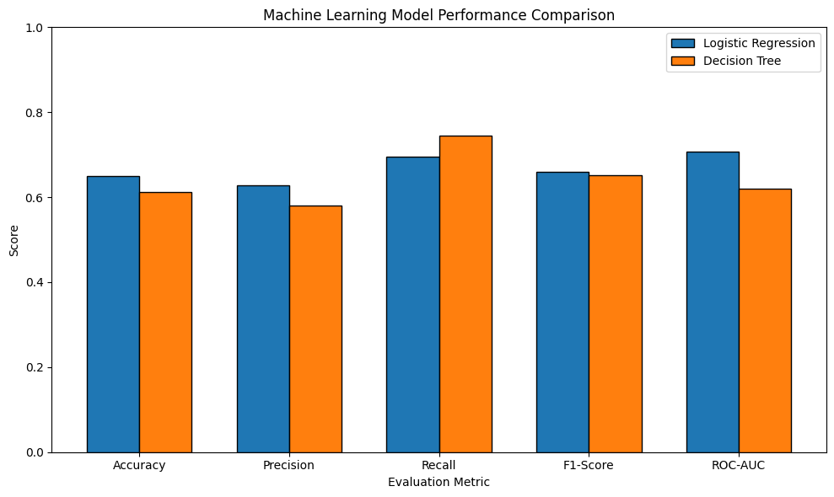
Figure 3: Performance Comparison of Logistic Regression and Decision Tree
Metric | Logistic Regression | Decision Tree
Accuracy | 65.07% | 61.24%
Precision | 62.83% | 58.02%
Recall | 69.61% | 74.51%
F1-Score | 66.05% | 65.24%
ROC-AUC | 70.76% | 62.01%
The results show that Logistic Regression performed better overall. It achieved higher accuracy, precision, F1-score, and ROC-AUC than the Decision Tree. The Decision Tree achieved higher recall (74.51%), meaning it identified a larger proportion of actual Higher Performance students. However, its lower precision and ROC-AUC indicate that this came with weaker overall classification performance. Based on the combined evaluation metrics, Logistic Regression was selected as the preferred model. In particular, its ROC-AUC of 0.7076, compared with 0.6201 for the Decision Tree, showed better overall ability to distinguish between the two performance groups.
Model Comparison Code Snippet:
comparison = pd.DataFrame({
"Metric": [
"Accuracy",
"Precision",
"Recall",
"F1-Score",
"ROC-AUC"
],
"Logistic Regression": [
accuracy,
precision,
recall,
f1,
roc_auc
],
"Decision Tree": [
tree_accuracy,
tree_precision,
tree_recall,
tree_f1,
tree_roc_auc
]
})
comparison.round(4)

FEATURE INFLUENCE ANALYSIS:
The Logistic Regression coefficients were examined to understand which selected features had the strongest association with the model's prediction of Higher Performance.
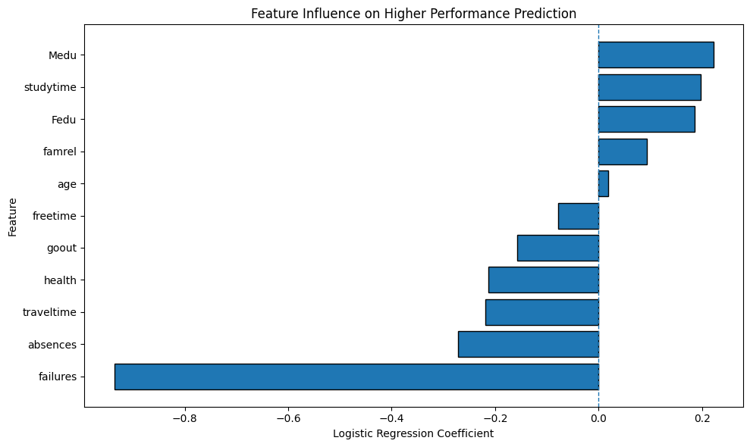
Figure 4: Feature Influence on Higher Performance Prediction
The strongest coefficient was for previous failures, with a value of -0.936. This indicates that, within the model, a higher number of previous failures was strongly associated with a lower predicted likelihood of belonging to the Higher Performance group. Other notable negative associations included absences (-0.272), travel time (-0.219), health (-0.213), and going out frequency (-0.157). Positive associations included mother's education (0.222), study time (0.197), and father's education (0.186). Age had the smallest coefficient (0.019), suggesting that it had very little influence on the model compared with the other selected features. Because the input features were standardized before training Logistic Regression, the coefficient magnitudes can be compared more meaningfully within this model. However, these coefficients represent associations used for prediction and do not prove that any factor directly causes student performance.

Feature Analysis Code Snippet:
coefficients = pd.DataFrame({
"Feature": features,
"Coefficient": logistic_model.coef_[0]
})
coefficients["Absolute_Coefficient"] = (
coefficients["Coefficient"].abs()
)
coefficients = coefficients.sort_values(
"Absolute_Coefficient",
ascending=False
)
display(coefficients)

OVERFITTING, LIMITATIONS, AND POTENTIAL SOURCES OF ERROR:
To check for possible overfitting, the Logistic Regression model's training and testing accuracy were compared. The model achieved 68.86% training accuracy and 65.07% testing accuracy, resulting in a difference of 3.79 percentage points. This relatively small difference suggests that the model did not suffer from severe overfitting and was able to generalize reasonably consistently to unseen test data. However, the testing accuracy remained moderate, and the overall error rate was 34.93%, meaning that 73 out of 209 test predictions were incorrect. The model produced 42 false positives and 31 false negatives. Therefore, although the model demonstrated useful predictive ability, it should not be considered highly reliable for predicting the performance of an individual student.
Several limitations may have affected the results. First, only 11 selected features were used, so other potentially important factors were not included in the model. Second, the combined dataset contained records from both Mathematics and Portuguese courses, and differences between subjects may influence student performance. Third, the binary cutoff of G3 = 12 simplifies student performance into two groups and may lose some information from the original numerical grades. The model could be improved by testing additional algorithms, performing hyperparameter tuning, adding carefully selected features, and using cross-validation for a more robust estimate of performance.

RECOMMENDATIONS FOR MODEL IMPROVEMENT:
Based on the evaluation results, several improvements could be considered in future work. The current Logistic Regression model achieved an accuracy of 65.07% and a ROC-AUC of 0.7076, showing useful but moderate predictive performance.
First, additional relevant features could be explored to provide the model with more information about factors associated with student performance. However, any additional variables should be selected carefully to avoid target leakage.
Second, cross-validation could be used instead of relying on a single train-test split. This would provide a more robust estimate of how consistently the model performs across different subsets of the data.
Third, hyperparameter tuning could be applied to both Logistic Regression and Decision Tree models. Other algorithms, such as Random Forest or Support Vector Machine, could also be tested and compared using the same evaluation metrics.
Finally, alternative approaches to defining the target variable could be investigated. Instead of dividing students into only two groups using the G3 = 12 cutoff, future work could explore different thresholds or predict the actual final grade using a regression model.

WORKLOAD AND TIMELINE:
The Week 4 machine learning task was completed within the expected 30–35 hour workload. The work was divided across the main stages of the machine learning pipeline.
Activity | Estimated Hours
Dataset loading, cleaning and preparation | 5 hours
Feature selection and preprocessing | 4 hours
Model selection and Logistic Regression training | 5 hours
Decision Tree development and comparison | 4 hours
Model evaluation and error analysis | 5 hours
Visualization and interpretation | 4 hours
Report writing and documentation | 5 hours
Final review and formatting | 3 hours
Total | 35 hours
The initial stage focused on loading the dataset, combining the Mathematics and Portuguese records, creating the binary performance target, and checking data quality. The next stage involved feature selection, data splitting, and feature standardization. A Logistic Regression model was then trained and evaluated using accuracy, precision, recall, F1-score, ROC-AUC, and a confusion matrix. Additional time was spent creating and interpreting the ROC curve, checking for possible overfitting, and analysing prediction errors. A Decision Tree model was also developed for comparison. Finally, feature coefficients were analysed, model limitations and possible improvements were discussed, and the results were documented. The work followed a structured process from data preparation to model evaluation and final interpretation.

CONCLUSION:
This project developed and evaluated machine learning models to classify students into Lower Performance and Higher Performance groups using selected student-related features. The analysis used 1,044 student records, with 11 features selected for model development. The dataset was divided into 835 training records and 209 testing records. Logistic Regression was selected as the primary model and achieved 65.07% accuracy, 62.83% precision, 69.61% recall, 66.05% F1-score, and a ROC-AUC of 0.7076. The model correctly classified 136 out of 209 test records. The training accuracy of 68.86% and testing accuracy of 65.07% differed by only 3.79 percentage points, suggesting no severe overfitting. The Decision Tree achieved higher recall (74.51%) but lower overall accuracy (61.24%) and ROC-AUC (0.6201). Therefore, Logistic Regression was considered the better overall model. The results show that machine learning can identify useful patterns in student performance data, but the 34.93% overall error rate demonstrates that the model still has important limitations. Previous failures showed the strongest negative association with predicted Higher Performance. Future improvements could include additional features, cross-validation, hyperparameter tuning, and testing more advanced algorithms.

